**Excercise 7a Date:**

**Develop low-fidelity paper prototypes for a banking app and convert them into digital wireframes using Pencil Project**

**AIM:**

The aim is to develop low-fidelity paper prototypes for a banking app and convert them into digital wireframes with Pencil Project.

**PROCEDURE:**

**Tool Link:** [**https://pencil.evolus.vn/**](https://pencil.evolus.vn/)

### **Step 1: Create Low-Fidelity Paper Prototypes**

1. **Define the Purpose and Features**:
   * Identify the core features of the banking app (e.g., login, account balance, transfers, bill payments).
2. **Sketch Basic Layouts**:
   * Use plain paper and pencils to sketch basic screens.
   * Focus on primary elements like buttons, menus, and forms.
3. **Iterate and Refine**:
   * Get feedback from users or stakeholders.
   * Iterate on your sketches to improve clarity and functionality.

### **Step 2: Convert Paper Prototypes to Digital Wireframes Using Pencil Project**

1. **Install Pencil Project**:
   * Download and install Pencil Project from the official website.
2. **Create a New Document**:
   * Open Pencil Project and create a new document.
3. **Add Screens**:
   * Click on the "Add Page" button to create different screens (e.g., Login, Dashboard, Transfer).
4. **Use Stencils and Shapes**:
   * Use the built-in stencils and shapes to create UI elements.
   * Drag and drop elements like buttons, text fields, and icons onto your canvas.
5. **Organize and Align**:
   * Arrange and align the elements to match your paper prototype.
   * Ensure that the design is user-friendly and intuitive.
6. **Link Screens**:
   * Use connectors to link different screens together.
   * Create navigation flows to show how users will interact with the app.
7. **Add Annotations**:
   * Include annotations to explain the functionality of different elements.
8. **Export Your Wireframes**:
   * Once satisfied with your digital wireframes, export them in your preferred format (e.g., PNG, PDF).

**OUTPUT:**

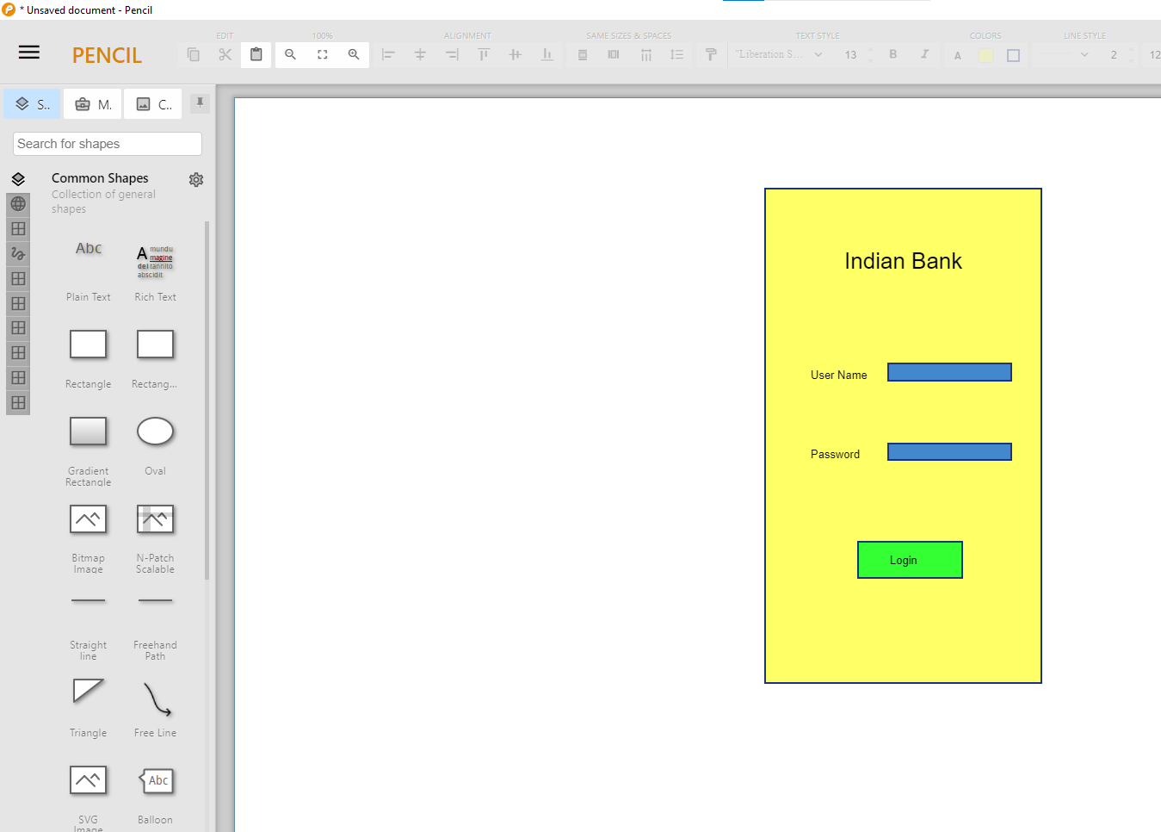

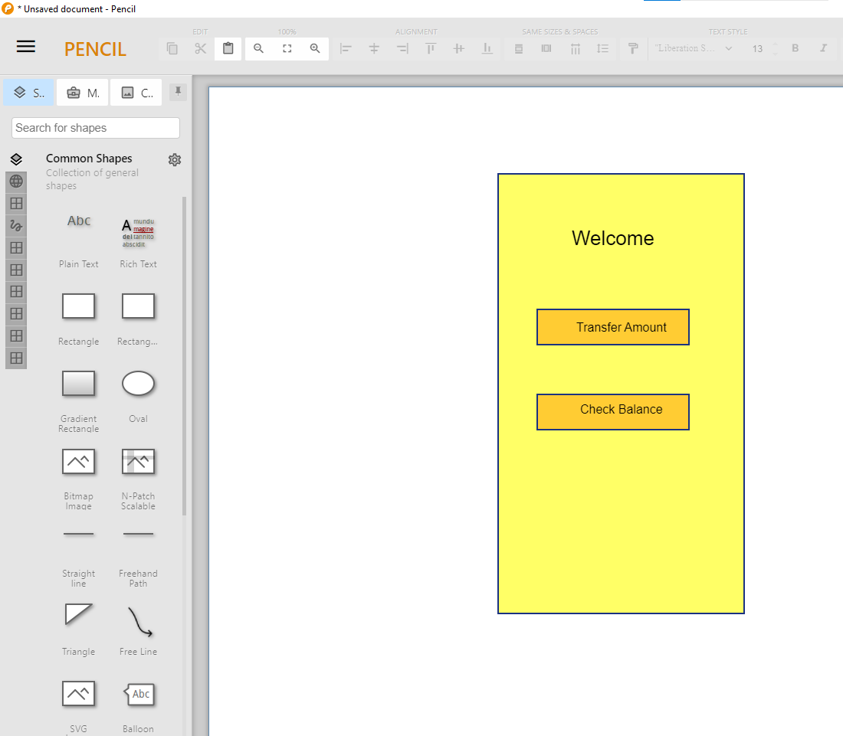

**RESULT:**

